1. 2016年3月，美国API公司总裁和工程师访华,在明程资源领导陪同下参观考察国内高纯铝生产企业-新疆众和有限公司及中铝包头铝业有限公司，各方就未来的合作事宜充分交换了意见并达成初步合作意向。
In March 2016, president and engineer of API from United States come to China and visit domestic high purity Aluminum manufacturers Xinjiang Joinworld Co.,Ltd and Baotou Alumunium Co.Ltd under Chinalco accompanied by BRL, After investigation and meeting, the potential HP Aluminum project info has been exchanged and preliminary cooperation agreement has been reached among the parties.

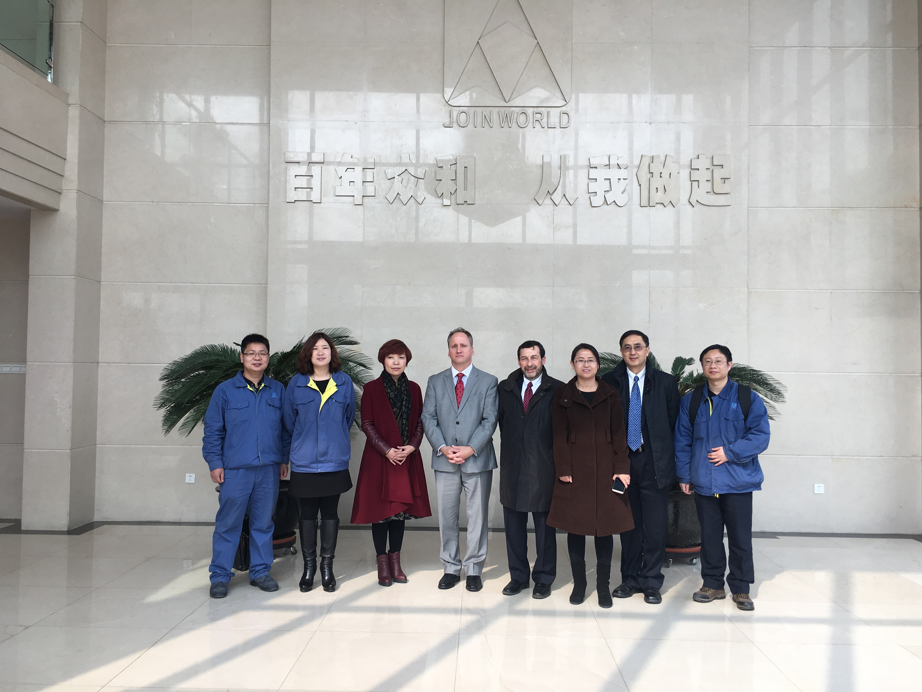

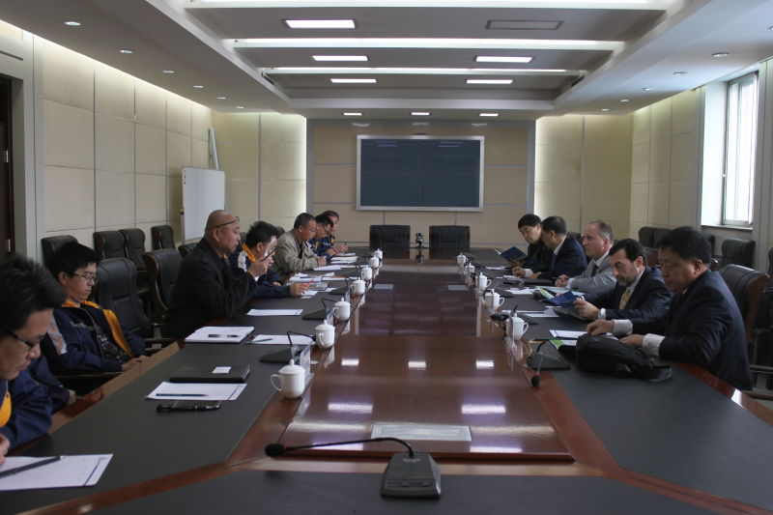

- 2016年1月，明程资源分别与包头铝厂和新疆众和集团双方领导会面，就高纯铝项目合作事宜进行交流, 双方一致同意三月份邀请外方项目公司代表来访以便进一步交流洽谈合作
In January 2016, Leaders of Baotou Alumunium(Group)CO.,Ltd & Xinjiang Joinworld Co., Ltd have a meeting with BRI respectively, and both sided exchange views on high purity Aluminum project and exploration future cooperation.Bothside agreed to arrange the USA party come to visit and further discuss cooperations.

- 2015年10月，明程资源有限公司成立，该公司专注广义的资源整合业务,立足自然资源贸易,并拓展资源,技术,人才,资本的资源整合.
Our subsidiary company Britway Resources Inc was established in October 2015 which is concentrated on generalized resources integration business.

